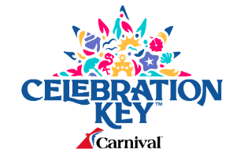

Vending Machines

December 2nd, 2024

**Request for Information (RFI)**

**Contact:** Rian Smith – rsmith3@carnival.com

**Responses due by:** December 9th, 2024

**SCOPE:**

In preparation for our launch date of Celebration Key in July 2025, Carnival is looking to place vending machines throughout the Carnival Key destination (ideally next to the public restrooms). This RFI (Request for Information) will be followed up by an RFP (Request for Proposal).

|  |  |
| --- | --- |
| **Company name** |  |
| **Contact Name** |  |
| **Contact Phone Number** |  |
| **Contact Email Address** |  |

**QUESTIONNAIRE:**

Please complete the following questions listed below:

|  |  |
| --- | --- |
| **#** | **CARNIVAL QUESTIONS** |
| **1** | # of years you've been in service |
| **2** | Are you a Bahamian owned company? If no, please explain. |
| **3** | Are you able to provide vending machines or kiosks for Celebration Key? If so, what type? |
| **4** | Have you provided vending machines to other companies similar to the size of Carnival? |
| **5** | What are the weather resistance conditions for the vending machines? |
| **6** | What relevant, active insurance(s) do you have? |
| **7** | Please share the dimensions or the different sizes of the vending machines you can provide? |
| **8** | Please provide 3 references. |

**SUBMISSIONS:**

Please email all submissions before end of day – December 9th to the following Team Members:

**Rian Smith**, Sr. Manager, Global Strategic Sourcing – Port Operations & Development - [rsmith3@carnival.com](mailto:rsmith3@carnival.com)