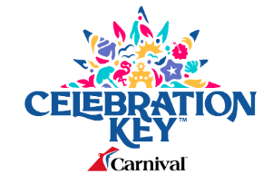

Onsite Car Rentals

December 2nd, 2024

**Request for Information (RFI)**

**Contact:** Rian Smith – rsmith3@carnival.com

**Responses due by:** December 9th, 2024

**SCOPE:**

In preparation for our launch date of Celebration Key in July 2025, Carnival is looking to contract onsite car rentals for our passengers and guests. This RFI (Request for Information) will be followed up by an RFP (Request for Proposal).

|  |  |
| --- | --- |
| **Company name** |  |
| **Contact Name** |  |
| **Contact Phone Number** |  |
| **Contact Email Address** |  |

**QUESTIONNAIRE:**

Please complete the following questions listed below:

|  |  |
| --- | --- |
| **#** | **CARNIVAL QUESTIONS** |
| **1** | # of years you've been in service |
| **2** | Are you a Bahamian owned company? If no, please explain. |
| **3** | Are you able to provide daily onsite car rentals for Celebration Key? If so, how many car rentals? |
| **4** | What type of vehicles can your company provide? |
| **5** | Are you able to provide an onsite representative to provide customer service to our guests? |
| **6** | What relevant, active insurance(s) do you have? |
| **7** | Have you worked with companies that are the similar size of Carnival? |
| **8** | Please provide 3 references. |

**SUBMISSIONS:**

Please email all submissions before end of day – December 9th to the following Team Members:

**Rian Smith**, Sr. Manager, Global Strategic Sourcing – Port Operations & Development - [rsmith3@carnival.com](mailto:rsmith3@carnival.com)